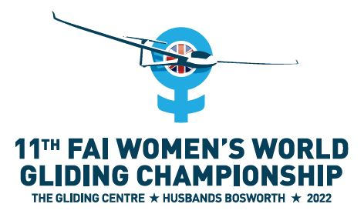

***Bulletin #1 August 2020***

**Welcome to Team Managers, Team Captains and Competitors**

We are delighted to invite all nations to compete in the 11th FAI Women’s World Gliding Championship at The Gliding Centre, Husbands Bosworth in August 2022. WWGC2022 will be an **international celebration of women gliding** in three classes – Club, Standard and 18m. **We would love to see more nations competing than ever before**, so especially if your nation doesn’t normally send a women’s team, **PLEASE** let us know if there is something we can do to help - we will do our best to make it possible!

**3 key things you need to know now:**

**1 Contacting Team WWGC2022**

You can email the organising team at [director@wwgc2022.co.uk](mailto:director@wwgc2022.co.uk) with any questions at any time! We ask team managers, team captains and competitors to subscribe to our mailing list at <https://www.wwgc2022.co.uk/competition-schedule/> so that you receive future bulletins and information swiftly.

**2 WWGC postponed to August 2022**

Due to COVID-19 and in line with all international gliding competitions, we have postponed WWGC2021: it is now WWGC2022 and will take place in August 2022. The new dates are as follows:

Monday 8 August 2022    Unofficial practice commences

Wednesday 10 August                        Official practice commences

Saturday 13 August                            Opening Ceremony

Sunday 14 – Friday 26 August            Contest Flying

Saturday 27 August                            Closing Ceremony

**3 Pre-WWGC practice opportunities in 2021**

All UK rated competitions have been cancelled in 2020, so we have postponed the pre-WWGC practice opportunities to summer 2021.  In particular we invite you to enter the HusBos Challenge Cup International which will now take place in August 2021 on the following dates:

Friday 6 August 2021 Pre-competition briefing (not mandatory)

Saturday 7 – Sunday 15 August Contest Flying

Sunday 15 August Prizegiving

The Challenge Cup is a very popular competition so please save the dates in your diary now! I will let you know as soon as we open the entry list – probably in September - **we will reserve places for WWGC entries until 31 December 2020**. If you entered the cancelled 2020 competition and asked for your entry to be deferred, you will automatically be added to the list for 2021 as soon as entries open.

Pilots may also wish to enter the UK’s 2021 National Competitions. The competition timetable is not yet finalised, but we expect HusBos to host at least one Nationals and other competitions to be flying in much the same task area. Please email us at [director@wwgc2022.co.uk](mailto:director@wwgc2022.co.uk) for help entering a UK Nationals. We will let you know dates and venues as soon as the competition calendar is published.

If you wish to come over **at** **any other time** for practice, please contact us and we’ll help you arrange your visit – we would love to see you in 2021.

That’s all from us for now – your next update will be when we have the 2021 UK Nationals calendar. Please sign up at **https://www.wwgc2022.co.uk/competition-schedule** to make sure you receive the latest news.

Until then, we wish you all happy COVID-safe soaring,

Best regards

Liz

Liz Sparrow, Contest Director, on behalf of Team WWGC2022

Email us: [director@wwgc2022.co.uk](mailto:director@wwgc2022.co.uk)

Website: www.wwgc2022.co.uk